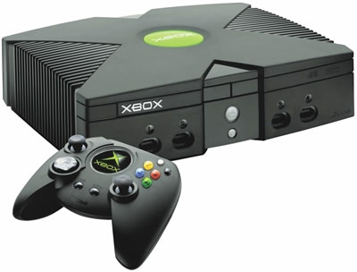**7 Resources of Technology**

Mr. Poliszuk

Technology 7

|  |
| --- |
| Identify the acronym used to help us remember the 7 Resources of Technology. |
| Choose appropriate emojis that represent each of the 7 resources of technology. |
| Choose a product, analyze its production and infer which types of specific resources were used in the development of this product.  Snip a picture of your product and paste here! |

East Lower School – Rochester City School District